11 I was given a reed like a measuring rod and was told, “Go and measure the temple of God and the [incense] altar, with its worshipers. ² But exclude the outer court; do not measure it, because it has been given to the Gentiles. They will trample on the holy city for 42 months. ³ And I will appoint my two witnesses, and they will prophesy for 1,260 days, clothed in sackcloth.” ⁴ They are “the two olive trees” and the two lampstands, and “they stand before the Lord of the earth.”[ ^{Zech. 4:3,11,14]} ⁵ If anyone tries to harm them, fire comes from their mouths and devours their enemies. This is how anyone who wants to harm them must die. ⁶ They have power to shut up the heavens so that it will not rain during the time they are prophesying; and they have power to turn the waters into blood and to strike the earth with every kind of plague as often as they want.
Who might the two witnesses be? Using “Scripture interprets Scripture,” what two people in the Old Testament mostly fit these characteristics?
1. Clothed in sackcloth (=calling people to repentance)
2. Stand in the Lord’s presence (Deut. 34:10; I Kings 19:10)
3. Proclaim fire that devours their enemies (I Kings 18)
4. Can shut rain up in the heavens (I Kings 17:1)
5. Can turn waters in to blood (Ex. 7:20)
6. Have every type of plague at their command (Ex.7-12)

Answer: If we have to pick two people to fit these descriptions, Moses and Elijah are the most likely (Moses and Elijah also brought their testimonies to the Mount of Transfiguration to testify that Jesus was the fulfillment of their ministries – Mark 9). However, the identity of the witnesses may ultimately be less important than their number (“at the mouth of two witnesses, or at the mouth of three witnesses, shall the matter be established” – Deuteronomy 19:15)
V.1 – measure the temple of God – in order to determine its boundaries (cf. v.2, “exclude the outer court”). See Ezekiel 40:1-5; Zechariah 2:1-5. By the measuring of the Temple, God promises that He will protect it (also the Church) and be its glory.
Are there senses / Scriptures in which the Gospel is inclusive (cf. Galatians 3:28)? Are there senses / Scriptures in which the Gospel is exclusive (cf.John 14:6)?
v. 2 – 42 months & v. 3 – 1260 days – the same amount of time. See chart on page 2.
v 4 - the two olive trees and the two lampstands – so that the olive trees feed the lampstands directly with the oil for the lamps.
NOTE: 1260 days / 42 months / “time, times, and ½ a time”
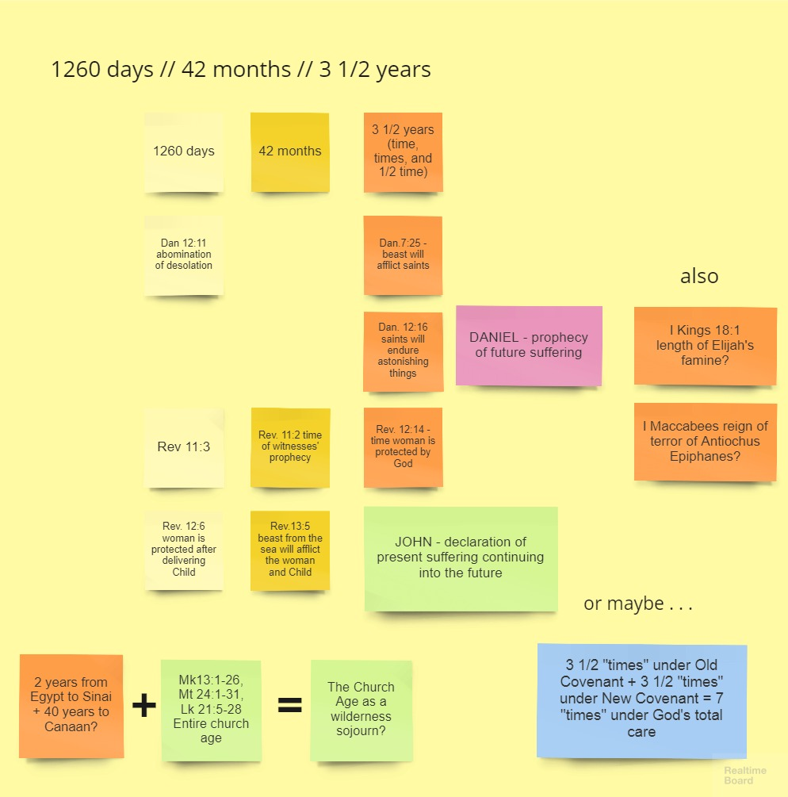
Brighton, p.299, on v. 9: “Though silenced, even their unburied bodies are a testimony . . . that haunts those who rejected their witness, for these people cannot quite stamp the witnesses’ testimony out of their memory. . . For the place and for the people of that place who heard their witness and then put to silence the voice of the church, that silence will endure . . . the people who live there and their children may not again have an opportunity to hear the Gospel voice of God.”
Brighton, p. 303: “The Christian church – composed of individual Christians – is always living in witness, dying for that witness, and being raised again for further witness.”
⁷ Now when they have finished their testimony, the beast that comes up from the Abyss will attack them, and overpower and kill them. ⁸ Their bodies will lie in the public square of the great city—which is figuratively called Sodom and Egypt—where also their Lord was crucified. ⁹ For three and a half days some from every people, tribe, language and nation will gaze on their bodies and refuse them burial. ¹⁰ The inhabitants of the earth will gloat over them and will celebrate by sending each other gifts, because these two prophets had tormented those who live on the earth.
v.7 - beast that comes up from the Abyss – Satan himself (ch. 10: )
v. 8 – great city . . . where also their Lord was crucified – Jerusalem. figuratively called Sodom and Egypt – Brighton, p. 298: “To reject the witness of the church is to come into a depraved and idolatrous state (like Sodom), resulting in a spiritual slavery (like bondage in Egypt).” For these reasons it is no longer proper to refer to this world’s Jerusalem as “holy.”
Spoiler alert: John has a much more vivid and detailed condemnation of Rome beginning in Revelation 14.
v.9 - will gaze on their bodies and refuse them burial – to refuse burial was to make the dead objects of shame and ridicule - See Ps.79:1-4.
v.10 – gloat and celebrate by sending each other gifts – Martin Franzmann calls this “a sort of anti-Christmas”
v.11 - after the three and a half days the breath of life from God entered them – one day for each year of their ministry; prophetic ministry does not end in death, but in resurrection and ascension (like Jesus’).
v.12 - they went up to heaven in a cloud – Cf. Mark 9:2-8. What did you suppose happened to Moses and Elijah when the Transfiguration was over?
¹¹ But after the three and a half days the breath of life from God entered them, and they stood on their feet, and terror struck those who saw them. ¹² Then they heard a loud voice from heaven saying to them, “Come up here.” And they went up to heaven in a cloud, while their enemies looked on.
¹³ At that very hour there was a severe earthquake^{[Haggai 2:6-7]} and a tenth of the city collapsed. Seven thousand people were killed in the earthquake, and the survivors were terrified and gave glory to the God of heaven.
severe earthquake - Listen to Handel’s Messiah, “Thus Saith the Lord”
¹⁴ The second woe (οὐαὶ; יאו) has passed; the third woe (οὐαὶ; יאו) is coming soon.
v. 14 - οὐαὶ; יאו – If you’re keeping track, the score is “Oy, oy.”
v.15 – The seventh angel sounded his trumpet – at last! But this is a different sign than the others! This is a “service plaza” of praise for believers, not a sign calling sinners to repentance.
Messiah – this little poem is actually contained within Handel’s Messiah, in the “Hallelujah Chorus.”
The sounding of the Seventh Trumpet announces the beginning of the reign of God, for which the singers thank God. The time of the anger and destruction of nations is now coming to an end, to be met with the time beginning with God’s wrath upon the destroyers of the earth (Revelation 15-16) and culminating with His rewards for His servants the prophets (Revelation 21-22)
v.19 – and there came – as on Mount Sinai, to let the people know that God was present on the Holy Mountain

¹⁵ The seventh angel sounded his trumpet, and there were loud voices in heaven, which said:
“The kingdom of the world has become
the kingdom of our Lord and of his Messiah,
and he will reign for ever and ever.”
¹⁶ And the twenty-four elders, who were seated on their thrones before God, fell on their faces and worshiped God, ¹⁷ saying:
“We give thanks to you, Lord God Almighty,
the One who is and who was,
because you have taken your great power
and have begun to reign.
¹⁸ The nations were angry,
and your wrath has come.
The time has come for judging the dead,
and for rewarding your servants the prophets
and your people who revere your name,
both great and small—
and for destroying those who destroy the earth.”
¹⁹ Then God’s temple in heaven was opened, and within his temple was seen the ark of his covenant. And there came flashes of lightning, rumblings, peals of thunder, an earthquake and a severe hailstorm.

