C:\STOCKLAYOUTS\CURRENT PROJECTS\FN99801-PL\FN99801-IMG08.emfC:\STOCKLAYOUTS\CURRENT PROJECTS\FN99801-PL\FN99801-IMG05.emf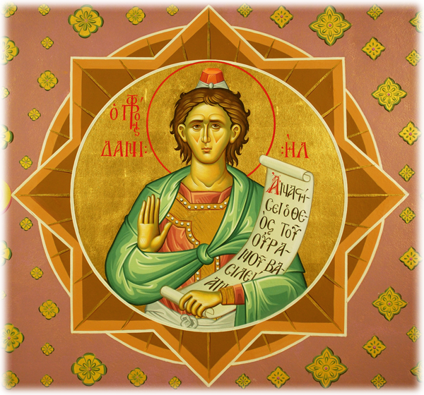C:\STOCKLAYOUTS\CURRENT PROJECTS\FN99801-PL\FN99801-IMG06.emf

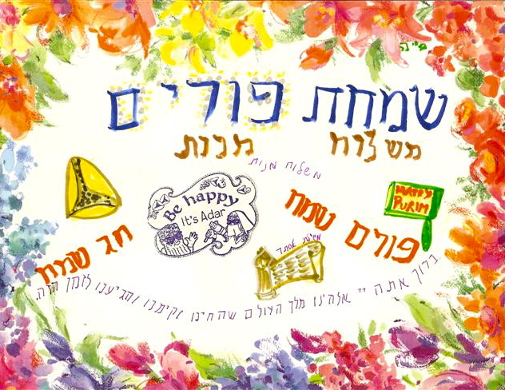

Royal Objectives.

Prophetic Solutions.

By the way . . .

פּורימשפּיל “Purim spiel” = “Purim play.” A play that tells the story of Purim, but may also have all kinds of satiric and comic additions as well. Sometimes, the story of Purim is only a pretext for lots of goofing around.

“Megillah” = a scroll, particularly the scroll of Esther, which is read completely from beginning to end in one sitting, twice, during Purim. (Hence the phrase “the whole Megilah.”)

1. Take a good look at the court of Xerxes in Chapter 1. Anything sound familiar?
2. Take a good look at the way Esther became queen in Chapter 2. How much does this sound like a fairy tale? How much does this sound like enslavement?
3. Take a good look at Chapter 3, especially verses 15-17. Although Mordecai thinks Esther is in the right position to help the Jews, she thinks that it’s the entire community that should be involved. What do you think?
4. Take a good look at Chapter 7 and Chapter 8. What do you think of the violent end of Haman and the enemies of the Jews?

Other Observations

Babylon

[www.handwritingonthewall.weebly.com](http://handwritingonthewall.weebly.com/)

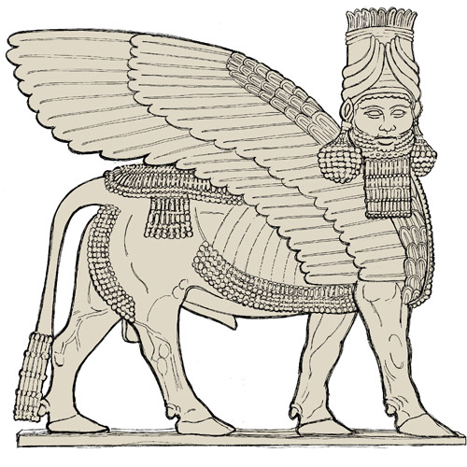

handwriting on the wall llc

Prophetic consultation services

The team at **Handwriting on the Wall Prophetic Consultation Services** is especially gifted by the Holy Spirit for these and other visionary needs. We offer a full range of Prophetic Consultation Services to the discerning despot and to the dedicated disciple, as described in the Case Study outlined inside.

See our other Projects and Case Studies at our website,

[www.handwritingonthewall.weebly.com](http://handwritingonthewall.weebly.com/)



handwriting on the wall llc

Prophetic consultation services

Case Study:

The Book of Esther

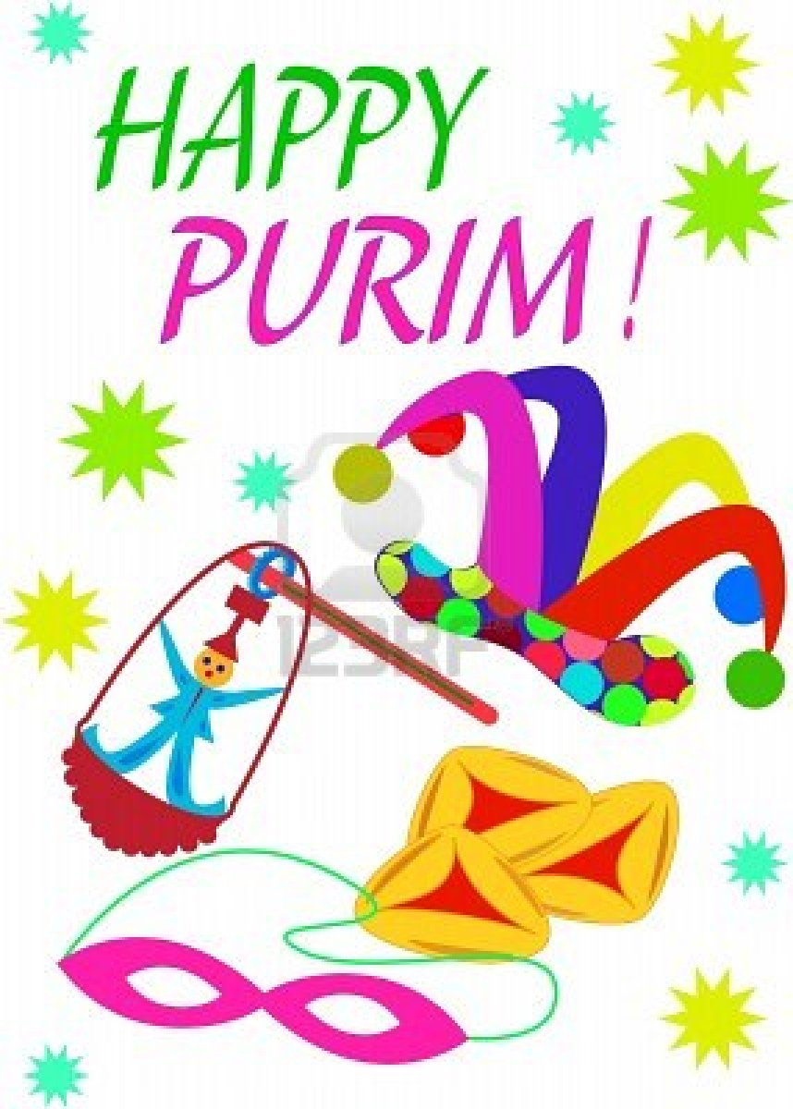

**Part III. THE 4 COMMANDS OF PURIM**

Megillah - Hear every word from the book of Esther

Mishloah Maanot– Send food to our friends

Matanot Le’evyonim– Give money to the poor

Mishteh – Have a good drinking party!

Most of today’s notes are taken from **Megillat Esther** By Rabbi Dr. Hillel ben David (Greg Killian) at

[http://www.betemunah.org/esther.html#_Toc287475188](http://www.betemunah.org/esther.html%23_Toc287475188)

**Part II. THE MEANING OF PURIM**

In Megillat Esther, neither **HaShem**, inner

spiritual, nor ethical values seem to determine the course of events, but rather external values, such as power, wealth, physical

beauty, sex (if you’re a man), and, more than anything else, luck, chance, or coincidence. Indeed, Purim means *chance* or *coincidence*, that is, the lots by which decided on which day the Jews should be destroyed.

On Purim we must drink enough wine so that we cannot tell the difference between “blessed is Mordecai” and “cursed is Haman”.

We dress in costumes to conceal who we are. Esther, when she went in to the inner chamber to visit “The King”, was not wearing makeup. There was simply herself without embellishment.

The Megillah of Esther is read at Purim. In the Megillah, Esther goes into the inner room and spoke with “The King”. It turns out that the Megillah describes the palace of “The King” with the exact same words that it describes the house of The Holy One.

In the Megillah of Esther we never see the name of **[HaShem](http://www.betemunah.org/hashem.html)**. When the Megillah is read, we blot out the name of Haman.

Mordecai refused to bow to Haman because Mordecai’s father, Benyamin, did not bow to Haman’s father, Esau. Esau was the father of [Amalek](http://www.betemunah.org/amalek.html) who was the father of Haman.



handwriting on the wall llc

Prophetic consultation services

**Part I: NAMES**

The [Talmud](http://www.betemunah.org/orallaw.html) offers as the origin of the name

Haman the verse in Bereshit (Genesis) 3:11

that refers to [Adam](http://www.betemunah.org/adam.html)’s sin: Hamin HaEtz hazeh (“from this tree”?).

Now we know that Haman is connected with the question regarding the Tree of the Knowledge of good and evil. The mystics call the Tree of the Knowledge of good and evil, “the tree of doubt”.

From the time that Adam ate from that tree, he had doubts, and **[HaShem](http://www.betemunah.org/hashem.html)** manifested Himself with doubts. After all, why did

[**HaShem**](http://www.betemunah.org/hashem.html)have to “ask” where Adam was? It is a cardinal rule of our faith that [**HaShem**](http://www.betemunah.org/hashem.html)

knows everything there is no doubt.

So, Haman was conceived in the garden

when Adam ate from the Tree of the

Knowledge of good and evil. Haman is the gap between ourselves and **[HaShem](http://www.betemunah.org/hashem.html)**.

*Devarim* (Deuteronomy) 31:16-18

Rashi makes the following comment on the above Torah verses: “During the time of Esther there will be a hiding of the face, and this will be a time of great troubles.”

The Hebrew word for *hide* is *esther*, so we have an allusion, in the Torah, to Esther, because in her day **[HaShem](http://www.betemunah.org/hashem.html)** did hide His face

to the extent that we do not find the name

of **[HaShem](http://www.betemunah.org/hashem.html)** in the book of Esther.

In fact, the disguises and the masks, of Purim, are all designed to underscore the essential hiddenness of this day.